The blue whale

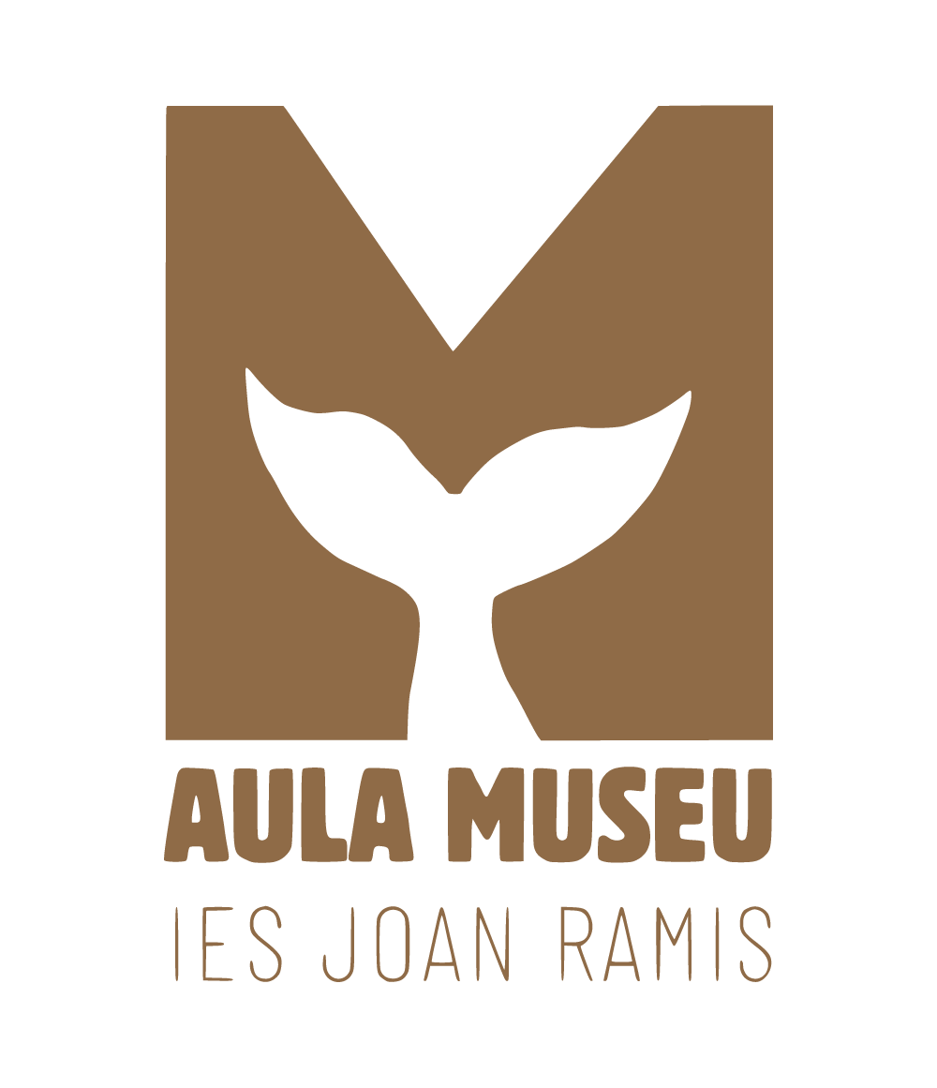

**Jhonatan Andres Ramirez**

**Web interface design**

**Irene Vinent Mercadal**

**Index**

**Logo and colors 3**

**Typography 4**

**color palette 5**

**Structure and spacing rules 6**

**Icons 7**

**Guidelines for Illustrations and Images 8**

**Style of interface elements 9**

## **Logo and colors**

|  |  |
| --- | --- |
|  |  |
|  | |

## **Typography**

Raleway Negro

123456789 Title

{/&@*#}

**Raleway Negrita**

**123456789 Subtitle**

**{/&@*#}**

Raleway normal

123456789 Content

{/&@*#}

Raleway Muy clara

123456789 secondary

{/&@*#} information

## **color palette**

#8F6B47 Main text and titles

#DF9D5D Main text

#F4D493 Extra color

#FFECD3 Background

#001A57 Highlight texts

## **Structure and spacing rules**

* Reducing the space between images or content and the edges of the page creates a modern and aesthetic style.
* A low and elegant header adds a modern and sophisticated design to the page. This type of header takes up less visual space, allowing the main content to stand out more.
* A rectangle that highlights the page you are on helps effectively guide the user.

## **Icons**

google icons

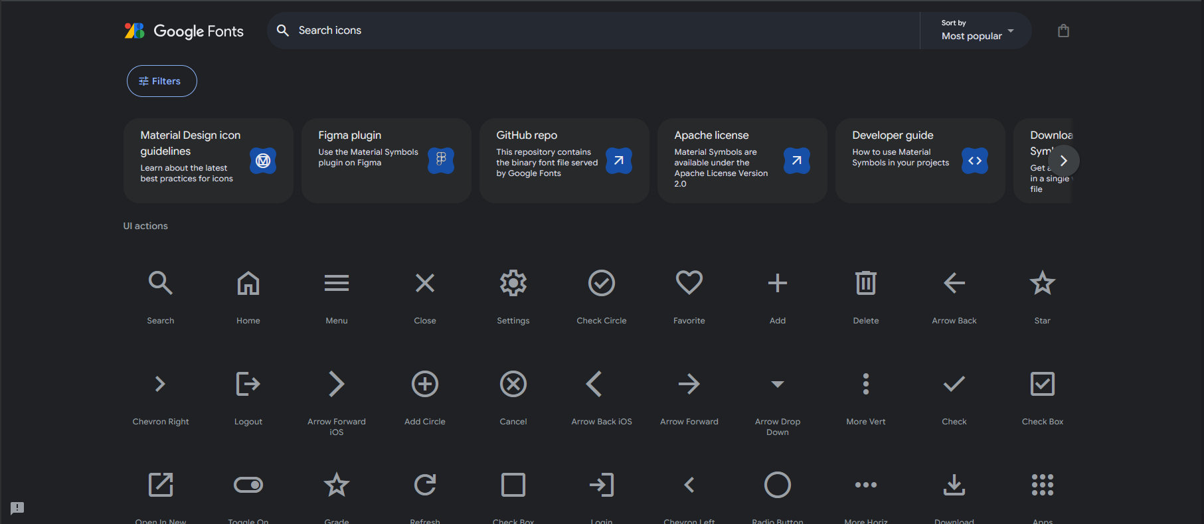

freepik (social networks)

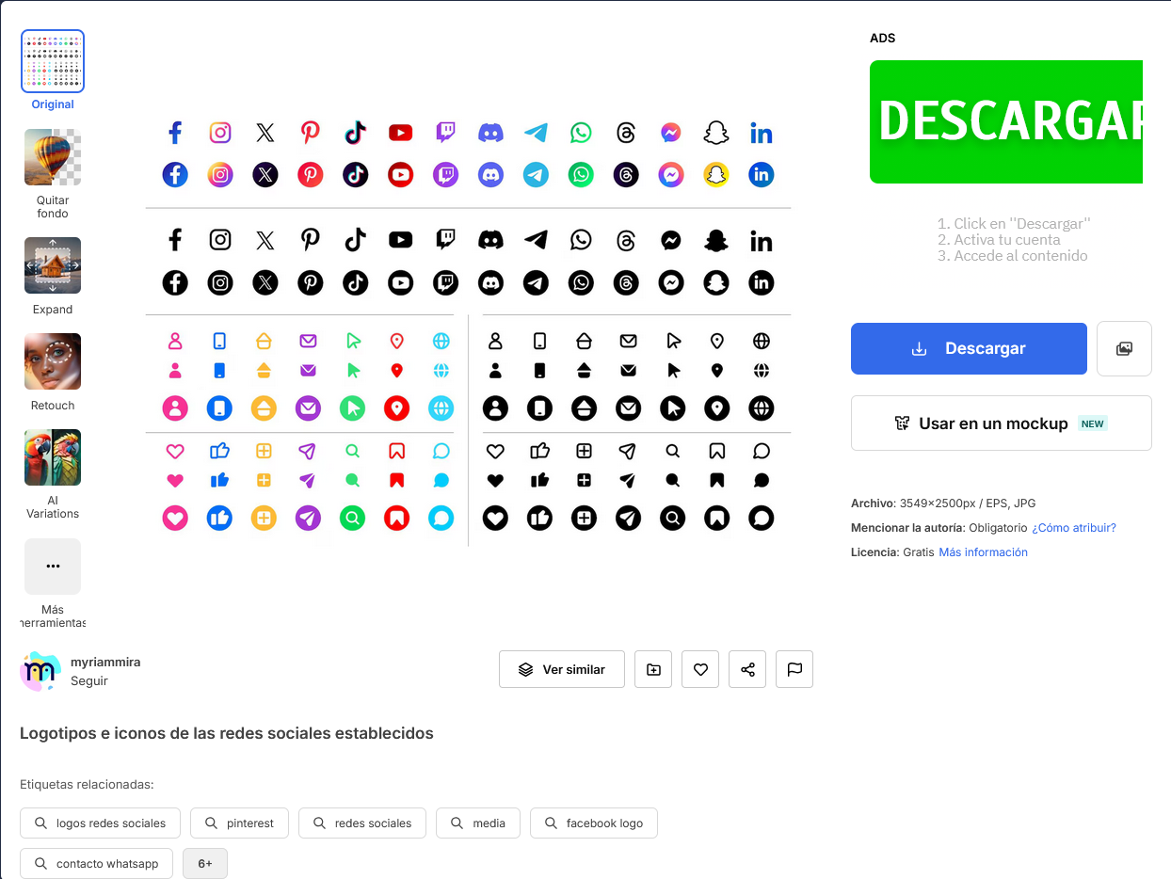

## **Guidelines for Illustrations and Images**

HISTORY page 1:1

PORTFOLIO page 1:1, 4:5 (horizontal)

NEWS page 4:5 (horizontal)

INSIDE THE NEWS page 1:1

AL VOLANT DE LA BALENA page 1:1, 4:5 (horizontal)

USER ICONS 1:1

In jpg, png or webp format and a maximum size of 1080 px.

small images such as the logo, icons, etc. at 150 px.

## **Style of interface elements**

## 

## 

